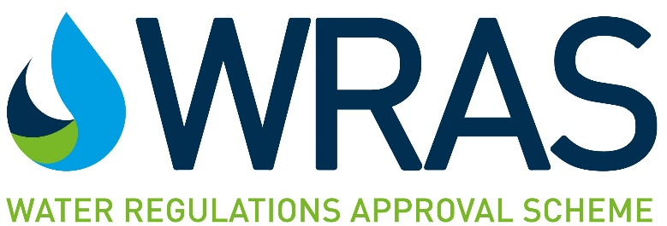

F2 Updated Declaration

The Water Regulations Approval Scheme (WRAS) approves water fittings and materials that meet the requirements of the Water Supply (Water Fittings) Regulations 1999, The Water Supply (Water Fittings) (Scotland) Byelaws 2014 and The Water Supply (Water Fittings) Regulations (Northern Ireland) 2009.
Water fittings must not waste, misuse, unduly consume or contaminate the water supply.
In order to assess this, fittings are tested against the performance requirements of the Regulators’ Specification and other relevant requirements of the Regulations.
WRAS Approval is granted to fittings that have been examined and found to fully satisfy the requirements of the Scheme.
WRAS introduced an updated application form with additional requirements and a modified declaration in July 2021. WRAS will accept applications submitted using the previous version of the application form under the conditions listed on the WRASapprovals.co.uk website.
The information detailed in the application will be used by the Scheme to produce your approval documentation and directory listing if your application is approved. You are therefore required to confirm the accuracy of all information provided by signing this declaration.
It is a requirement that you must notify the Scheme of any changes to the information detailed in the application during the assessment of the product and throughout the period for which the Approval is valid.
Please confirm that the application submitted contains the following:
(select the boxes below to indicate that you have included all of the information required)
☐ A completed copy of the F2 application form version 8.3 Nov 2019
(Please ensure you fill in every section indicating ‘not applicable’ if appropriate)
☐ General assembly drawings of the product, e.g. cross-sectional drawings
☐ Technical drawings of the product and any backflow arrangements
☐ Itemised schematic of full water pathway
☐ Installation manuals, where applicable, for all items relating to the application.
(Installation manuals are applicable if they include technical specifications, safety and performance information)
☐ A minimum of 1 photograph or technical drawing of the product identification mark
☐ Representative photograph of the products included in the application:
Do you wish this to be placed in the public domain on the WRAS website? YES ☐ or NO☐
☐ A completed “Schedule of Materials”
☐ Copy of ISO 9001 certificate or equivalent

All applications for WRAS Approval are subject to the Standard Terms and Conditions of WRAS Approval Schemes amended from time to time (“Standard Terms of Approval”). These are available from the WRAS Approvals website.
(Please be aware that failure to include any of the items listed above and the provision of the signed declaration will result in a delay when processing your application.)
F2 DECLARATION

I / we, the Applicant named in section 3 of the F2 (version 8.3 Nov 2019) Form, for the product with sample number: declare as follows:
- I/we have read and understand and accept the terms applicable to applications for WRAS Approval as set out in the Standard Terms of Approval and agree to comply with the Requirements and Code of Practice for WRAS Approvals;
- I/we confirm that where a WRAS Material Approval number or BS6920 test report is included in this application, the material used in the product remains identical to the material tested or the currently approved WRAS material. No ingredients have been added, directly or indirectly during the manufacturing process and the material has not been modified in any way.
- I/we confirm, that where any BS6920 test report submitted is over two years old, that no changes to formulation, site or method of manufacture or supplier of raw material have been made.
- Unless otherwise indicated in the Schedule of Materials submitted with this application, I/we confirm that where a component is manufactured from Polyphenyleneoxide (PPO), Polyphenylene Ether (PPE) or Polyoxymethylene (POM), the component has a wetted surface area of less than 3,000mm².
- If our product(s) seeking approval should fall under the scope of the following legislation: GB Biocidal Products Regulation, I/we acknowledge that it is our sole responsibility to ensure that compliance with this has been met and that WRAS are not responsible for confirming this. Where our product(s) fall under this legislation we will declare this within the application. I/we understand that WRAS may draw attention to the fact that the product(s) fall under the GB Biocidal Products Regulation within the approval listing.
- I/we warrant the accuracy and completeness of all information contained in the Form F2 and any other information now or subsequently provided by me/us and/or our Agents to WRAS and/or the relevant test facility in pursuance of this application and confirm that none of this information is or may be construed as misleading in any way.
- The Agent whose details are set out in section 4 of the Form F2 is duly authorised to represent and answer all queries on behalf of the Applicant in relation to this application. I/we, the Applicant, agree to ratify all acts and omissions of the Agent in connection with this application and to indemnify WRAS for any losses incurred as a result of any breach of the Standard Terms of Approval by the Applicant and/or our Agent(s).
Signed:
Name:
Position in company:
Date:

Important Note: This declaration should be signed by a director or an authorised permanent employee of the Applicant.
An agent appointed by the applicant may sign on behalf of the Applicant only if a separate declaration is provided by the applicant on company headed paper. The declaration must be signed by a director, or authorised employee of the Applicant, and state:

“I/we declare that the signatory on the F2 form, (agents name and company), is an individual who is authorised to execute a binding document on behalf of the applicant, i.e. an authorised signatory. I/we understand that if there are any errors/omissions/inaccuracies contained within the application signed by ‘agents name and company’, then the approval granted will be invalidated”
NOTE: THE REQUIREMENTS AND THIS SIGNED DECLARATION SUPERSEDE ANY PREVIOUSLY PROVIDED DECLARATIONS.

